1. State and briefly describe the 2 parts of the nervous system.  
   CNS: ________________________________________________________________________________________  
   PNS: ________________________________________________________________________________________

Read ‘Nerve cells’ section and answer the questions below.

3)  
a) What is the name given to nerve cells and what do they make up? _______________________________________

b) What is the job of the nerve cells? ________________________________________________________________

c) What is the name given to the electrical messages transmitted by neurons? _______________________________

d) A neuron is a type of animal cell. Name 6 parts of a neuron.  
___________________________________________________________________________________________

e) Which of the above parts are specialised for neurons? ________________________________________________

f) Briefly describe the structure of a neuron. Include the terms **cell body, dendrite** and **axon.**______________________________________________________________________________________________________________________________________________________________________________________

g) There are different types of neurons. State the role of the following neuron types.  
Motor neuron: _______________________________________________________________________________  
Connector neuron: ____________________________________________________________________________  
Sensory neuron: ______________________________________________________________________________

h) Why does your body need to control which nerves ‘fire’ at a certain time?  
______________________________________________________________________________________________________________________________________________________________________________________

i) Label the following neuron.

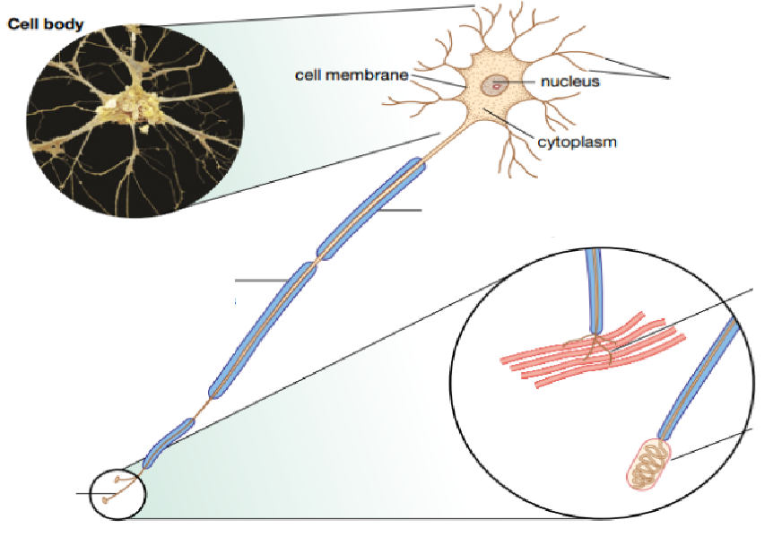

j) Complete the sentences.  
When the nerve impulse reaches the __________________________ at the end of an axon, a chemical called a _____________________________ is released into the space between the ______________________________  
This space is called a __________________________. The ________________________ carries the message from the axon of ___________________________________________________. The dendrite receives the __________________________________________________.

k) Neurons bundle together to form what? ____________________________________________________________

l) Define the following terms:  
Dendrite: ___________________________________________________________________________________  
Myelin sheath: _______________________________________________________________________________  
Synapse: ____________________________________________________________________________________  
Neurotransmitter: ____________________________________________________________________________  
Sensory receptor: _____________________________________________________________________________

4) Using the terms **Central Nervous System**, **Peripheral Nervous System**, **Motor Neuron**, **Connector neuron** and **Sensory neuron,** describe the order of events that happen when you are in a dark room and then a light turns on.  
_______________________________________________________________________________________________________________________________________________________________________________________________________________________________________________________________________________________________________________________________________________________________________________________________________________________________________________________________________